Merry Christmas



Welcome to the first Trust-wide Southern Health and Social Care Trust edition of News and Views for People with a Visual Disability.

Please contact us if you would like the Newsletter in another format:
Audio tape, Email/CD (Microsoft Word), or Braille.

December 2008
The Southern Health and Social Care Trust - incorporates the former Newry & Mourne, with Armagh & Dungannon and Craigavon & Banbridge Health and Social Service Trusts.

Mr Pat McAteer has been appointed as the Head of Sensory Disability Services. Pat is responsible for the management of services for Blind and Partially Sighted People and Deaf and Hard of Hearing People.

Liz Tanner has been appointed as the new Visual Disability Team Leader. Liz will be responsible for the daily management of staff and services for Blind and Partially Sighted People.

Armagh & Dungannon:
Denise Lavery, Pamela Clarke, and Russell Lucas. Based at:

Moy Resource Centre; Dungannon Road; Moy, BT71 7SN. TEL: 028 8778 4832.

Craigavon & Banbridge:

Beverley Lappin, Doreen Brown, Doreen McFarland, Irene Montgomery, John Fogarty, and Ray Maxwell. Based at:

Cherrytrees Resource Centre; 1a Edenderry Gardens; Portadown BT63 5EA. TEL: 028 3839 4088.

Newry & Mourne:

Bronagh Lynch, Danny McSherry, Donal Connolly, Eimear O’Hanlon, and Padraig McLoughlin. Based at:

Conifers Resource Centre; Drumalane Road; Newry; Co. Down. TEL: 028 3025 0800.

Contents

Page 1 Cover
Page 2 Visual Disability Team
Page 3 Contents
Page 4 Tips and other information
Page 5 – 8 Age Related Macular Degeneration
Page 9 – 11 RNIB information
Page 12 +13 News on DLA
Page 14 – 16 Information on Guide Dogs
Page 17 – 19 Focus Summer Scheme
Page 20 Fit 4 U Project
Page 21 – 22 Computer Qualifications
Page 23 + 24 BT information
Page 25 Arts & Disability Forum
Page 26 + 27 Transport Matters
Page 28 + 29 Low Vision Clinics
Page 30 Information on Postal Votes
Page 31 – 34 What is on in your area?

Tips and other information

A useful tip has been passed along from Mrs Dolores Rafferty, Dungannon.

“If you are having difficulty with bump-on’s staying on your cooker – then why not try using some ‘No more nails adhesive’ to keep them stuck on. Dolores has tried and tested this method and it really does work.”

Do you have any other tips or useful information that you could share with people with a visual disability?

If so, please contact any of our staff we would welcome any information for the next edition of the Newsletter.

Contributions

Special thanks to everyone who has either contributed an article to this edition of the newsletter, or have been consulted concerning the content.

Age-related macular degeneration (AMD)

What is it?
The macula is located at the back of the eye at the centre of the retina. It enables us to see fine detail and objects directly in front of us. It plays a vital role in helping people to read, write, drive and perform other detailed tasks. It also enables us to recognise faces and see colour.
There are two types of AMD:
Dry AMD is the most common form of the condition. Cells in the retina fail to function properly as a person gets older. The cells do not take in enough vital nutrients and fail to clear by-products of cell functioning. This causes tiny abnormal deposits, called drusen, to be left under the retina, making it uneven.
In time, retinal cells degenerate and die causing sight loss. This occurs very gradually over many years.
Wet AMD accounts for 10 to 15 per cent of cases. It often develops quickly and is also known as 'neovascular AMD' because it involves the growth of new blood vessels behind the retina.
These new blood vessels are very fragile and so may leak fluid or blood. This results in scarring that causes rapid visual loss.

What causes it?
It is unclear what causes AMD. It becomes more likely as a person ages because, over time, the cells in the macula become damaged and worn out.

What are the symptoms?
Both eyes are usually affected, although one eye may be affected before the other. The good eye usually compensates for the affected eye and for many years this can disguise the fact that there’s a problem. There is no pain or redness of the eyes.
Any activity that requires detailed, clear vision is compromised, and in the late stages of the disease sight loss is so severe that patients are offered registration as partially sighted or blind.

Who's affected?
In developed countries it’s estimated that one in 50 people over 50 years of age, and up to one in five people over the age of 85 have AMD.
A person is at greater risk of developing AMD if they smoke, have high blood pressure, or someone in the family has the condition.

What's the treatment?
Currently, there's no medical treatment for dry AMD. However, not smoking and eating a healthy diet may help to slow the rate of deterioration. High doses of beta-carotene, vitamins C and E, and zinc may help to slow down visual loss for some people who already have AMD.
Additional lighting and magnifiers can help those with AMD to make better use of their residual sight.
Medical breakthroughs in the treatment of wet AMD mean that, in most cases, treatments can prevent further visual loss, and in some cases restore partial sight.
There are three types of treatment for wet AMD:
- Photocoagulation uses a hot laser to seal leaking blood vessels, but can only be used in a minority of cases where the leakage is not directly in the centre of the macula.
- Photodynamic therapy (PDT) uses a cold laser to seal leaking blood vessels. This involves injecting a drug that reaches and coats the abnormal blood vessels via the blood stream. The drug is then activated by shining a light at the coated blood vessels and it destroys them.
- Anti-vascular endothelial growth factor (anti-VEGF) treatments target a protein involved in the formation of new blood vessels. High levels of VEGF can cause proliferation of blood vessels and fluid leakage. The drugs are injected under the macula. The number of injections varies. In trials the injections were given either every four or every six weeks, but in practice clinicians have to decide on the most appropriate treatment regime based on their assessment of the patient’s response to the drugs. Anti-VEGF treatments have been shown to halt sight loss and in some cases restore it.

A new drug treatment for wet AMD, called anecortave acetate, aims to stop new blood vessels forming, but is injected behind the eye rather than into it. Currently, it’s only at the experimental stage.

Can it be prevented?
Apart from the growing risk as people age, there appears to be a genetic influence that significantly increases the risk of developing AMD, particularly if other risk factors are present. While ageing and genetic predisposition can’t be modified, other risk factors can.
Smoking – people who smoke at least double their risk of developing AMD. The risk may be as high as 34 times that of a non-smoker if there’s also a family history of AMD.
When people stop smoking the risk decreases, but this can take up to 20 years so it’s important not to start.
Ultraviolet (UV) light – although it’s thought that UV light doesn’t reach the retina, and so doesn’t increase the risk of developing AMD, wearing high-quality sunglasses in bright sunlight is recommended to protect eye health generally.
Nutrition – the role of vitamins and minerals and antioxidants in helping to prevent AMD isn’t clear. Some scientific evidence suggests a diet rich in antioxidant vitamins and minerals may help reduce the risk of a person developing AMD, although other studies suggest the scientific evidence isn’t strong enough to recommend this.
However, a diet rich in antioxidant vitamins and minerals is unlikely to cause any harm. It makes sense to eat plenty of fruit and vegetables each day, particularly kale and leafy green vegetables. People with moderate AMD, should consult a doctor before taking additional amounts, especially high-dosage supplements.
“Far sighted Professor Ian Grierson of Liverpool University Department of Ophthalmology, believe that eating veg can reduce the risk of developing AR Blindness. He’s created a cookery book, Vegetables for Vision (£17 including P+P, from www.maculardisease.org; 01264 350551). High on his list are spinach, cress, red peppers, celery and lettuce.” Sainsburys’ Magazine September 2008.

Advice and support

Royal National Institute of the Blind
Tel: 0845 766 9999
Email: helpline@rnib.org.uk
Website: www.rnib.org.uk

Macular Disease Society
Tel: 0845 241 2041
Email: help@maculardisease.org
Website: www.maculardisease.org

RNIB – Information

New Eye Clinic Liaison Officer

My name is Diane Hudson, I have recently been appointed as an Eye Care Liaison Officer (ECLO) for the RNIB and will be based in the Southern Trust.

I am a Registered Nurse, and for the past 17 years I have been working in Ophthalmology. My career in eyes began in Moorfields eye hospital London back in 1991. I left London and began working in the eye department of the Royal Victoria hospital Belfast, where I worked for the past 11 years. Prior to my appointment as ECLO I was a deputy clinical sister in eye casualty at the RVH. As a nurse in a busy outpatient department I rarely got time to converse with patients and actually find out how their sight loss was affecting them on a daily basis. The ECLO role means I am able to spend time with people, discover their individual needs, and provide information, advice, and support as necessary in order to meet these needs.

My role as the Eye Care Liaison Officer is to offer a point of contact for anyone seeking emotional support, further help, or assistance for themselves or their carers.

For anyone with sight loss I can provide support by;

Giving you an opportunity to discuss:
- How people are coming to terms with sight loss
- Any concerns

Providing information and advice on:
- Benefits entitlement
- Appropriate services
- Training opportunities
- Rights under current legislation

Supplying information on:
- Eye Conditions
- Eye Health

Making contact with community services on your behalf:
- Assisting you access sensory support services which provide specialist rehabilitation and mobility training
- Providing a confidential service

I will be present at the following clinics:

- Monday: Mr Page’s clinic at Daisy Hill Hospital
- Tuesday: Miss Knox’s clinic South Tyrone Hospital
- Wednesday: Miss Knox’s clinic at Armagh Community Hospital
- Thursday: Mr Murphy’s clinic at Craigavon Area Hospital

When I am not present at a clinic, a referral can still be made to me through nursing or medical staff. Individuals seeking advice can contact me independently. I will follow the referral up with a phone call as soon as possible. Referrals are accepted from any source. The service information and my contact details will be available at each clinic.

If anyone wishes to speak to me, just ask any member of staff within the eye clinic or approach me directly. No matter how trivial or serious an issue seems please feel free to discuss it with me.

My contact details are:

E-mail diane.hudson@rnib.org.uk
Tel no. 028 90 329373 (Belfast Office)

CVC – Community Vision Co-ordinaters

My name is Russell Lucas and I am the Community Vision Co-ordinater (CVC) for RNIB NI in the Armagh and Dungannon locality. Doreen McFarland is the CVC for the Craigavon and Banbridge locality, while Danny McSherry is the CVC for the Newry and Mourne locality.

We aim to promote social inclusion and independent living by assisting Blind and partially sighted people to make use of available services and activities within the local area. E.g.
- Education
- Sport
- Leisure
- Training

We also provide information on local community services and activities and assist and facilitate the local Visually Impaired Groups within the area.

A CVC can be contacted at any of the Resource Centres.

Wraparound

The Wraparound project provides support to blind and partially sighted children through the RNIB Children's and Youth Team.

The team provides family weekends, family fun days, youth residentials and summer schemes as well as information, advice and signposting for families to other relevant organisations.

For more information about our service please contact Rosaleen Dempsey at RNIB on 02890329373 or on 07939300949.
Local Blind and Partially Sighted People attend RNIB Mass Lobby on Disability Living Allowance (DLA) at Westminster Hall, Houses of Parliament.

The lobby has been called by RNIB, Action for Blind People, Guide Dogs for the Blind, and other Associations. All of these organisations believe that the current DLA mobility component system is unfair and is failing people with severe sight loss.

Why are we lobbying?
In December 2006 we held the largest ever lobby of Parliament by blind people. The Lobby convinced the Government that it needed to look again at the exclusion of people with severe sight loss from receiving the higher rate mobility component of DLA. Since then RNIB has been working with DWP Ministers and officials for 18 months to find a solution that is both workable and affordable.

The lobby is a crucial step in our campaign. We have just learned that, despite saying that they understand our argument and are sympathetic to our aims, the Government says that they are unable to commit to amending the DLA system at this time. Officials, with whom RNIB has been working for 18 months to find a solution that is both affordable and workable, have recommended to Ministers that the changes we have sought should be made. The change would cost between £30-45 million for all of the UK, this is a tiny amount of money, less than 0.25 % of the social security budget

This made our Lobby of Parliament on 15th October even more important. We were delighted with the massive turnout from all over the UK and especially the group of 20 that travelled over from Northern Ireland to support the Lobby; this was our chance to show the Government how angry we are, that have fought hard to get this far and will carry on fighting until they put right the current injustice.

Included in the RNIB NI group were four VIPs from the Newry and Mourne area.

From Warrenpoint we had Berni Sloan and Elizabeth Farquhar. From Newtownhamilton Laura O'Reilly and from Bessbrook Fiona McHale. In their company was the RNIB Community Vision Co-ordinator for their area Danny McSherry. We met no fewer than 8 Northern Ireland MPs: Lady Sylvia Hermann (UUP); Mark Durkin and Eddie McGrady (SDLP); and Messrs Dodds, Donaldson, McCrea, Simpson and Wilson (DUP).

The RNIB chief executive Lesley-Anne Alexander had this to say. "I would like to thank everyone who took part in the Disability Living Allowance (DLA) lobby. 1,500 blind and partially sighted people from across the UK travelled to Westminster to lobby their MPs to increase DLA for people with sight loss. This was undoubtedly the largest lobby by blind and partially sighted people ever, and I was very proud that so many staff came to support this event."

For further information, please contact Helen Dearman in the RNIB Campaigns Team phone number is London 02073881266.

Guide Dogs for the Blind

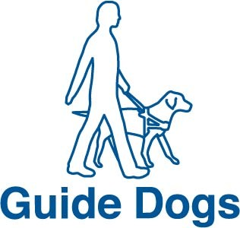

Myths about Guide Dog ownership

In 2009 Guide Dogs will celebrate 25 years in Northern Ireland. During that period we have trained over 300 people and currently have around 90 active partnerships. However, we firmly believe that there are more people who could benefit from the increased confidence and independence that owning a guide dog brings and therefore we hope to expand our services in the near future.
With this in mind we thought it might be a good time to look at some of the common questions and myths which have prevented or delayed people from seeking further information or applying for a guide dog in the past. The most common 5 are -

1 – Can’t only people who are registered or totally blind apply?

This is a very common myth. Each person’s visual impairment is as unique as their fingerprints, as are the effects, and there is not a fixed point on a scale where a Guide dog becomes appropriate. We have owners with a wide range of visual abilities. Only a very small percentage of people have no sight whatsoever and the vast majority of Guide Dog owners do have some residual vision. For example, someone might be able to read the phone book but restricted peripheral vision would mean they could not travel safely without a mobility aid. We carry out a thorough assessment with every person based on their individual circumstances. Applicants do not have to be registered blind or partially sighted.

2 – Can guide dogs work in rural areas?

This is another common question. It is certainly true that some areas pose particular difficulties in working a dog and occasionally it isn’t possible. Often however, specific training can make working a dog in a rural area possible. In other cases a dog may provide valuable independent travel a little further away from the home area.

3 – Aren’t guide dogs just for younger people who are in work?

Although people do need to be aged over 16 there is no upper age limit for applicants. We have trained people in their 70s, 80s and even 90s. Some dogs get people to their place of work or may travel with their owners all over the country and beyond. Other partnerships get to the shops a couple of times a week, with walks for exercise in between. In both of these hypothetical cases the improvement in the quality of life for the Guide Dog Owner is the important issue, rather than the destination or distance travelled.

4 – Can people with other disabilities train with a guide dog?

Yes. As an organisation we pride ourselves in training people with a wide variety of additional disabilities including clients who are deafblind, are amputees, have a learning disability or a brain injury. We have started to breed labradoodles – a cross between a Labrador and Poodle, which shed very little hair primarily for people who are asthmatic or who are allergic to dog hair.

5 – Don’t people have to undertake long cane training before applying for a guide dog?

Although this question often comes up it is not a requirement that applicants receive long cane training before applying. That said it is often beneficial as the skills developed are transferable to working with a guide dog. Long cane training is useful, but not essential. When appropriate we offer long cane and other orientation and mobility input as part of the assessment and training process.

In conclusion there are no hard and fast rule as to what makes a successful guide dog applicant. All our enquirers are viewed and assessed individually. Anyone aged over 16 and living in the UK who has a mobility problem stemming from their visual impairment is entitled to be assessed for a guide dog.

If you would like to receive more information about owning or applying for a guide dog we would love to hear from you.

Guide Dogs in Belfast can be contacted on 02890 471453 or by email at dt.northernireland@guidedogs.org.uk

Focus Summer Scheme - has been organised for four years for blind and partially sighted children, who live within the Craigavon & Banbridge area.

The aim of the Summer Scheme is to promote personal development and empower the young people to be active in their communities. Provide information that is relevant to the lives and interests of club members. Offer Challenging and fun leisure activities.

This year the scheme was opened up to all blind and partially sighted children and some children with a hearing loss (between the ages of 8 – 18), who live in The Southern Health & Social Care Trust area.

Seventeen children attended this year’s scheme, which took place between the 4th and 8th August. Children travelled to the Summer Scheme from Armagh, Banbridge, Coalisland, Dromore, Lurgan, Portadown and Warrenpoint. The Summer Scheme was based in Goodyear Sports Club Craigavon, with events taking place at Portadown Golf Club and Craigavon Water Sports Centre.

This year the scheme was supported by Wraparound through the RNIB, who not only provided valuable funds, but more importantly made available staff and volunteers to assist with the activities throughout the week. The scheme was led by Ray Maxwell with support from staff within Cherrytrees Physical Disability Team, and staff from Moy Resource Centre.

Special thanks has to be extended to Portadown Golf Club, who hosted a full day’s Tri-golf event, which was free of charge. The Golf Club generously provided free refreshments for all the children and helpers who attended this event, as well as instruction from their club professionals David Hughes and Peter McCelland.

Another special mention has to go to Michael Ruddy and Robert Geary from Craigavon Sports Development Team who hosted an activity session on the last morning of the scheme. The activities included: parachute games, traffic lights games, and introduced two new games: New Age Kurling, and Boccia to the children.

During the week the children took part in two Art and Crafts workshops during which they completed six stain glass windows. The workshops were led by Janet Crymble MFA, who has exhibited her work both nationally and internationally, and has also been involved in leading Community Arts Projects for over eleven years.

Janet said she was “enlightened” by the children’s enthusiasm, and their capability to use various materials to produce each window. They learnt how to use colour in a different sense to produce stain glass panels, which take on a different appearance in sunny conditions.

This was both an enjoyable and educational activity that aimed to encourage each of the children to work to their full potential. To help achieve this aim, each panel depicts a famous individual with either a sight or a hearing loss. For example the following famous individuals were chosen: Louis Braille, Stevie Wonder, Dame Evyleen Glinny (deaf), David Blunkett, Janet Gray, and Marie Matiland (deaf).

Can you guess what they are famous for?

Answer: Louis Braille invented Braille which is a combination of raised dots that represent letters of the alphabet. Stevie Wonder singer, Dame Evyleen Glinny percussionist, David Blunkett MP – Education Secretary, Home Secretary and Secretary of State for Works and Pensions. Janet Gray five times world disabled water skiing champion, and Marie Matiland actress, who starred in ‘Children of a Lesser God’.

Other activities undertaken were water sports i.e. Banana boating and canoeing, and indoor games. The week was brought to a close by treating all the children, leaders, helpers, and volunteers to a group meal at the Seagoe hotel.

Pictured here are two of the stain glass panels:

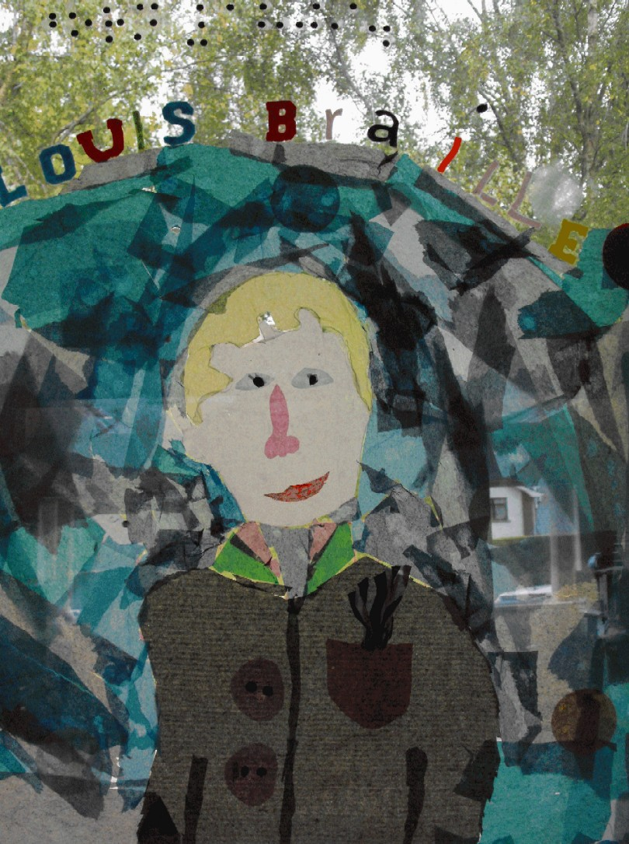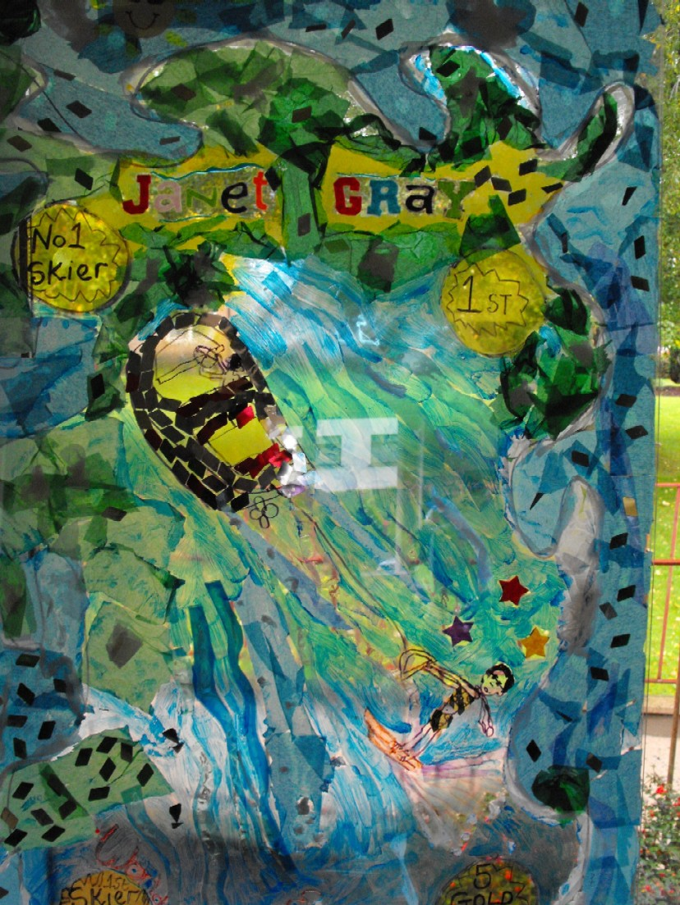

Louis Braille Janet Gray

The Fit 4 U Project aims to introduce people with physical and sensory disabilities from Willowbank, Station Road and Moy Resource Centres, to a range of new opportunities in physical/Leisure activities and address wider lifestyle issues and improve overall health and wellbeing.
Activities include:
Circuit Training
Archery
Boccia
New Age Kurling
Walking
Cycling
Golf
Dance
Sailing
The Project is a partnership project, involving Moy Resource Centre, Willowbank Resource Centre, Station Road Resource Centre, Armagh City & District Council, Dungannon & South Tyrone Borough Council, Southern Health & Social Care Trust and Southern Investing for Health Partnership.
For further information contact:
Rhonda Richardson
'Fit 4 U' Project Worker
Armagh & Dungannon Health Action Zone
26 Dungannon Street
Moy
BT71 7SH
Tel: 028 8778 9531
Fax: 028 8778 9527

Students with a Visual Impairment Achieve Computer Qualifications at
Southern Regional College

In May 2008 an awards ceremony was hosted at Southern Regional College, Newry Campus for people with a visual impairment who completed OCR level one Certificate in Computer for Beginners.

This is the fourth year of the course which encourages people with a visual impairment to learn computer skills and achieve relevant qualifications. These qualifications help to enhance their quality of life through extended communication skills via internet and e-mail.

The course was established in response to a request from a group of individuals with a visual impairment living in the area who wanted a computer skills course set up to meet their particular needs.

With the support of Insight Training, the college purchased specially adapted software and equipment that allows students to hear the course instruction from customised tapes and where applicable to use magnification software.

Students progress from becoming competent, keyboard touch typists to qualifying on the certificated computer course of choice. Two of the students have excelled further, in also achieving their European Computer Driving Licence (ECDL) qualification.

Students taking part have made the following comments about their experiences “the class has given me the opportunity to learn new skills. It has also given me confidence to make new friends”
Another student has found the course a great asset saying “I am now secretary of two voluntary organisations and learning how to use the computer has made these roles more accessible.” ……..

“I have really enjoyed this service provided by Southern Regional College. We all work at the same level and no-one is made feel any different”

“I have learned something I never thought I would be able to do”

“Having some computer knowledge is becoming necessary for everybody in today’s world “‘I am so glad I took the plunge. I really enjoy the class I have never felt under pressure to do any of the qualifications’”

Since the course commenced in 2004, more people with a visual impairment are showing an interest in learning how to use a computer. We would like to take this opportunity to encourage any of you who have even a slight interest or who have any questions about computers or training courses to contact any of the Rehabilitation Workers in your local Resource Centre

For more information please contact either:

Rita Byrne, Southern Regional College, Newry Campus, 028 3025 9717, or

Bronagh Lynch at Conifers Resource Centre,
028 3025 0800.

BT Services

Audio CD bills from BT

In 1992 BT was one of the first utilities to offer bills in Braille and large print. Bills on floppy disk that could be read by a Computer using screen reader software followed later but advances in technology have made CDs even more attractive.

BT has now taken steps to provide bills on audio CD and provide total bill information, which had not previously been available on audio formats.

The CD contains three formats:

An audio CD file, an MP3 file and a text file. This multi-file format enables customers to play the CD on a number of devices: CD and DVD players and PCs, and the text file is compatible with screen reading audio software on a PC. This innovative new format will help people with reduced visual, cognitive or dexterity capabilities to access comprehensive billing information.

The audio CD gives information on charges for call packages and individual calls, BT Total Broadband and value-added services such as BT Digital Vault and IT Home Advisor, as well as direct debits paid, outstanding payments and credit balances. The synthesised 'voice' has been developed to be as close to a person's voice as technically possible with features such as local rather than phonetic pronunciation of place names.

Audio CD bills are available free of charge to anyone who registers with them via www.bt.com/inclusion or by calling 0800 800 150.

An audio CD version of BT Update will automatically be included as will a standard copy of the bill. The talking bill service will still be available for people who prefer it but bills on floppy disk will be phased out during 2008.

BT Basic- a helping hand from BT

Next month BT will launch its new social telephony scheme which provides a telephone service to those who are truly vulnerable and clearly have affordability issues.

BT Basic is a low-cost phone package that has specifically been designed by BT, working closely with telecoms regulator Ofcom, to help customers keep in touch with family and key contacts such as doctors and teachers, although money might be a bit tight.

The service has been developed so that all the phone costs are very clearly priced. The package is made up of a low-cost line rental and a call allowance. Calls made above the allowance are at a set rate so you can always keep track of your spending and keep within budget.

BT Basic is only available to customers who receive one of

The following benefits: Income Support, Income-based Job-Seeker's Allowance or Guaranteed Pension Credit. Some exclusions to the scheme will exist concerning certain types of BT lines and service from other suppliers. BT Basic also excludes discount schemes like Friends and Family or the BT Calling Plans.

Visit www.bt.com/btbasic for more information. To see the information in BSL click the BT Sign link on
www.bt.com/inclusion.
Arts & Disability Forum

The Disability Forum offers people with a disability, who are artistic and working in any art form, an opportunity to apply for an Arts and Disability Award. The Arts and Disability Awards are a partnership between the Arts Council of Northern Ireland, Arts Council/An Chomhairle Ealaion and the Arts and Disability Forum.

‘Fly Your Kite!’ is the newsletter for the Arts & Disability Forum. It is available in E-mail, Braille, large print. Floppy disk, Audio tape/CD and simplified text and pictures.

In the Spring /Summer edition, Mr Cathal Og, a successful applicant for the award, discussed his work as a song writer and the following extract is taken from of one of his pieces. We hope it will inspire you to develop your hidden talents.

Dan and Annie by Cathal Og
She sits rocking by the fire
Outside the snow is getting higher
She knows wait
Is all she can do.
………

Now they go walking, hand in hand
Up through the hills, along the sand
They’re with the eagle.

The last three years have seen a steady emergence of Cathal from a highly isolated, anxious and imprisoning place, to a fuller engagement with the world ‘My aim in life was to be invisible’.

Now through the award, Cathal is truly finding his voice.
This is an example of how one man faced his fears

TRANSPORT MATTERS

Smart Pass for people who are registered blind

The Smart pass was introduced by the Department for Regional Development in June 2003. The Concessionary Travel Smart pass is issued to prove eligibility for free travel and must be presented on every journey.

Anyone Registered Blind (by a Consultant Ophthalmologist) is entitled to apply for free bus and train travel. Application forms can be obtained from your local Visual Impairment team who will also countersign the form confirming you are registered blind.

Half Fare Concessionary Smart pass

You can apply for half fare Smart pass if you are eligible under the following categories

- If you are registered partially sighted with the Health & Social Services Trust
- in receipt of either high or low rate mobility component of DLA for minimum period of 12 months
- - if you have been refused a driving licence on medical grounds by the DVLNI
- If you are known to the Health & Social Services Trust as having a learning disability.

Application forms can be obtained from your local Visual Impairment team.

All Ireland Travel Scheme

Since April 2007 older people have been able to travel anywhere in Ireland by public transport for free. In order to qualify for this you must have a Senior Smart pass. Application forms can be obtained from your local Translink Office.

Door-2-Door Transport

The Door-2-Door transport is available to anyone living within a 2 mile radius of the town centre, providing they come under one of the following categories:

- Registered blind
- Age 80 or over
- Disability Living Allowance high rate of mobility component
- Disability Living Allowance high rate of care component
- Attendance Allowance high rate

If none of these categories apply, you can complete a section to enable your GP to provide information on your illness/disability to explain why you cannot use public transport.

The Door-2-Door transport is available in the following towns within the Southern Health & Social Services Trust area

- Armagh
- Dungannon
- Newry
- Portadown
- Lurgan

Further information from Door-2-Door Transport, Department for Regional Development, Room 309, Clarence Court, 10-18 Adelaide Street, Belfast. BT2 8GB
Telephone 028 90540609
Email door2door@drdni.gov.uk

LOW VISION CLINIC

There are Low Vision Clinics in the following hospitals:

South Tyrone Hospital
Daisy Hill Hospital
Craigavon Hospital

If you are having difficulty reading even with your spectacles, you may benefit from the use of magnification.

What is Low Vision?

Many people with sight loss have difficulty completing daily tasks like reading, writing and getting out and about.

95% of those experiencing visual loss have some vision that is of practical use. This is known as Low Vision.

The Aim of the Clinic

- To help promote independence
- Improve quality of life

Who Will I See?

- A Senior Optometrist will assess your vision and demonstrate and provide magnifying aids or glasses if appropriate.
- A Rehabilitation Worker from your local Resource Centre is present to give advice on the practical difficulties you may be experiencing.

How can you help the Low Vision Clinic?

If you cannot keep your appointment at the Clinic contact the secretary in plenty of time so that another appointment can be arranged.

Please inform staff at the clinic if you change your address and telephone number

Please bring your glasses or low vision aids if you have them with you to your appointment.

For further information or referral to the Clinic contact your GP, Optician, Eye Specialist or staff at your local Resource Centre.

PERMANENT POSTAL VOTE – BLINDNESS OR DISABILITY

You can apply for a permanent postal vote if your blindness or other disability is either permanent or is going to continue for at least two years. Please contact the Helpline telephone number: 0800 4320712 or visit the website www.eoni.org.uk for the correct form.

If you are registered as blind with a Health and Social Services Trust or you are in receipt of the higher rate component or a Disability Living Allowance (DLA) you do not need to have your application attested by a qualified person, provided you send evidence that you are registered or in receipt of the allowance with your application. That evidence could be an official letter or other document making it clear that you are registered blind or in receipt of the DLA (high rate)

In other cases you must have Section 4 of the form completed by a qualified person. Some individuals may charge a fee for completing the form. You should ask whether there will be a fee before asking someone to complete Section 4 for you. The guidance notes that accompany the postal vote form, will state who can sign the form.

What’s on in your area?

Armagh

Orchard Social Club for Visually Impaired People.

The Orchard Club is open to Visually Impaired People living in the Armagh District Council Area.

The group meets on the first and third Tuesday afternoon of each month in Dobbin Street Community Centre, Armagh.

Activities include:

- Speakers to the Club

- Outings to the Theatre

- Christmas dinner.

For further information contact the Chairperson:
Dr Anne Beamish TEL: 028 3752 5708.

Banbridge

V.I.P. Club Programme
Dec 2008

Wednesday

3rd December Commons Band

17th December Xmas Party
Banbridge Hockey Club

7th January Music Night – David Ferguson

Luncheon Club – Belmont Hotel 12.30

Thursday
11th December
15th January

For further details please contact Club Chairperson

George Magowan

TEL: 028 4062 2149

Craigavon and Banbridge

Tandem Walking Club

Date | Walk | Lunch Venue
10 Dec | Bann Towpath | Portadown Golf Club
28 Jan ‘09 | Bocombra - Rushmere | Loughview

Some venues may be subject to change. For further information please contact Staff in the Visual Disability Team at Cherrytrees Resource Centre
TEL: 028 3839 4088.

Craigavon Area

Cane & Able Sports Club for Visually Impaired People.

The Cane & Able Club meets from 10.30 – 12.30 most Tuesdays mornings in Cascades Leisure Centre, Thomas Street, Portadown.

Activities include:

- Lively conversation over a cup of tea or coffee
- Indoor Bowls
- Swimming
- Armchair Aerobics
- Annual outing to places of interest
- Christmas Party

For further information please contact the Club Secretary: Mrs May Gough TEL: 028 3833 3840.

Newry and Mourne VIP Club

The Newry and Mourne V.I.P. Club, for blind and partially sighted people, meets on the first Tuesday of every month from 7.45 pm until 10pm. The Club runs a selection of social, informative and physical activities. The following is the list of events until the summer…

December 2nd: Christmas Party in Bellini’s, Newry
January 13th: Bowling, Orchard Centre, Newry
February 3rd: Balmoral Hotel, Warrenpoint
March 3rd: Exercise class, Orchard Centre
April 7th: Kilmurry Arms, Kilkeel
May 5th: Therapies, Orchard Centre
June 2nd: Cross Square Hotel, Crossmaglen
July 7th: Local History, Orchard Centre

If you are interested in joining the Club please contact the staff at the Conifers Resource Centre in Newry.

If you have any ideas or suggestions that the club might be able to organize please contact one of the following committee members,

Charlene Newell, Chairperson: Phone 028 4176 9239

Laura O’Reilly, Secretary: Phone 028 3087 9329
E-mail: oreillyl@talktalk.net

The Club would like to thank the Trust, the volunteer bureau, the senior citizens consortium, the Lyons club and the Lundy family for their continued support.
We hope you have enjoyed reading our news letter. As you are aware this is the first Trust-wide edition and we are keen to ensure that everyone will benefit from the information provided.
We very much welcome your views on any of the articles and what you feel should be included in future editions.
If you have any suggestions please contact Ray Maxwell, Rehabilitation Worker based at Cherrytrees Resource
Centre 02838394088

